BIG DATA LAB-04

Switching to database

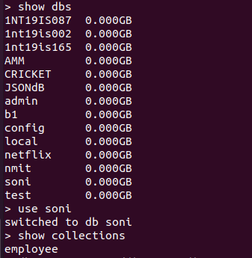

Values in tables

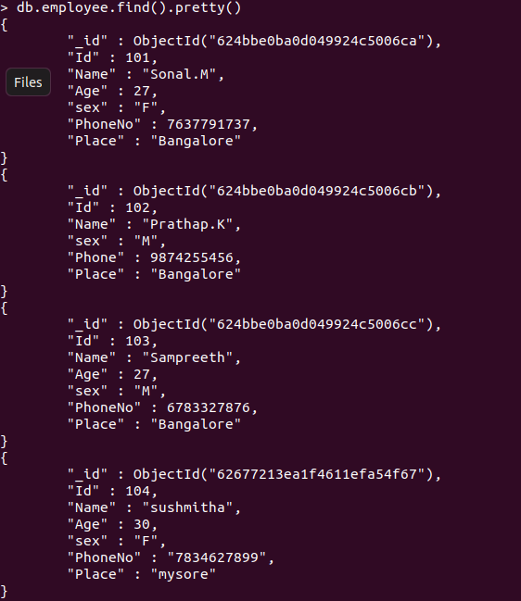

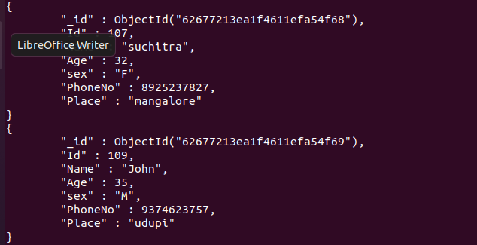

MAP REDUCE:-

1. SUM

> var mapFunctional =function(){ emit (this.Id,this.Age); };

> var mapFunction1 =function(){ emit (this.Id,this.Age); };  
 > var reduceFunction1=function(keyId,valuesAge) { return Array.sum(valuesAge); };  
 > db.employee.mapReduce( mapFunction1, reduceFunction1, {out:"totals"});  
 { "result" : "totals", "ok" : 1 }  
 > db.totals.find()

OUTPUT

{ "_id" : 101, "value" : 27 }  
 { "_id" : 102, "value" : null }  
 { "_id" : 107, "value" : 32 }  
 { "_id" : 103, "value" : 27 }  
 { "_id" : 104, "value" : 30 }

{ "_id" : 109, "value" : 35 }

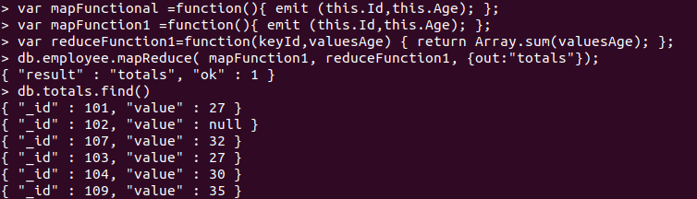

2)AVERAGE:-

> var mapFunction1 =function(){ emit (this.Name,this.Id); };  
 > var reduceFunction1=function(keyName,valuesId) { return Array .avg(valuesId); };  
 > db.employee.mapReduce( mapFunction1, reduceFunction1, {out:"totals"});  
 { "result" : "totals", "ok" : 1 }  
 > db.totals.find()

OUTPUT

{ "_id" : "suchitra", "value" : 107 }  
 { "_id" : "Sampreeth", "value" : 103 }  
 { "_id" : "Prathap.K", "value" : 102 }

{ "_id" : "Sonal.M", "value" : 101 }

{ "_id" : "sushmitha", "value" : 104 }  
 { "_id" : "John", "value" : 109 }

